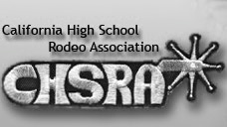

California High School Rodeo and Cargill present the CHSRA Special Rodeo.

SPECIAL RODEO ENTRY FORM

Contestant Name: ___________________________________________________________ Age: __________

Years attended any CHSRA Special Rodeo: ________________________________________________

Address: ______________________________________________________________________________________

Email Address: _______________________________________________________________________________

Please note below any special accommodation(s) the contestant may need:

Parent(s) or Guardian(s) Name: ____________________________________________________________

Home Phone:______________________________________ Cell Phone: _____________________________

Email Address: _______________________________________________________________________________

