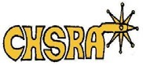
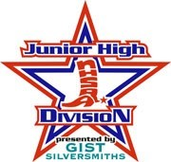
CJHRD STATE FINALS
ORDER OF EVENTS*

Thursday, May 18, 2018
Friday, May 19, 2018

Track Arena Big Arena

Boys Breakaway Roping Pole Bending

Boys Goat Tying

Girls Breakaway Roping Bareback Steer Riding

Girls Goats Tying Saddle Bronc Steer Riding

Bull Riding

Tie Down Roping

Ribbon Roping

Team roping

Chute Dogging Barrels

*Subject to Change (listen for announcements)

Saturday, May 20, 2018
Order of Events TBA

